Role Profile - Youth Arts Worker - Visual Arts, Arts and Craft *
Job title | Youth Arts Worker - Visual Arts, Arts and Craft | Salary: | Up to £10.55 an hour
Reporting to: | Arts Coordinator | Holidays: | 33 days including bank holidays (pro-rata)
Location: | Future Youth Zone | Hours: | Between 9 to 26 hours per week, evenings and weekends. *Multiple positions available.
The Person: | Do you want to use your artistic and creative talents to make the lives of young people better? Are you fun, vibrant, creative and committed to supporting young people and nurturing talent and do you have a range of visual arts skills to offer young people?
Key Relationships: | Core Management team, Youth Work Managers, OnSide, External Stakeholders, Young People and Parents.
Key Dates and application details: | Closing date: 9 am, 31st January 2019.  Interviews will be held during the day on the 9th or 10th February, or on the evening of the 12th or 13th February 2019.  To apply, please complete the Sessional application form, which can be found on our website. Your completed form should be sent by email to Future Youth Zone’s Business Operations Manager: jane.vickers@futureyouthzone.com

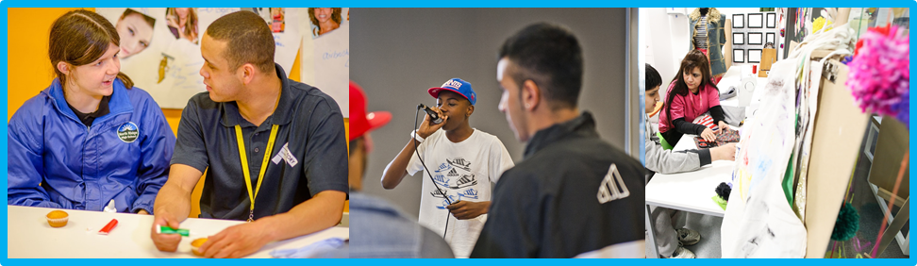

Job Purpose:

The Arts, alongside sport and Youth Work, is at the heart of Future’s offer to young people. The Arts offer is wide ranging and includes visual arts, music, media, dance and drama. As a member of Arts Team, based in the Arts Room and leading on visual arts, you will be key in ensuring young people have access to an exciting and creative arts programme that will be challenging, stimulating, fun, engaging and developmental. You will be involved in teaching the fundamentals of a single, or range of arts activities, enabling young people to explore their creativity and grow their skills.
Within the arts team we are looking for a range of talented youth arts workers to make up a team with a diverse set of skills and expertise, who are also passionate about working with young people. Ideally, you will have experience delivering one or more of the following arts:
- Visual arts (painting, drawing, sculpture, set design, etc)
- Photography
- Textiles
- Fashion
- Costume design

Context of the post:
Barking and Dagenham Youth Zone, named “Future” by local young people, will be the first Youth Zone in London opened by the national charity, OnSide in Spring 2019. This is an exciting and unique opportunity to join the delivery team pre-opening and play your part in history, shaping opportunities for London’s young people and supporting full time Youth Workers and Youth Work Managers.
The Future, like all OnSide Youth Zone’s, exists to give young people, particularly those who are disadvantaged, somewhere to go, something to do and someone to talk to. Each Youth Zone is open 7 days a week, at weekends and during school holidays. The Youth Zone’s purpose is to help young people grow to be happy, healthy and successful adults.
Future’s state-of-the-art £6.5 million building on Parsloes Park, will provide young people with access to a range of activities, offering them the opportunity to try new things, meet new friends and gain support from friendly, warm and positive staff and volunteers. The facilities include a 3G pitch, a gym, sports hall, recreation area and dance, arts, music and media suites, with state-of-the-art facilities equipped for a wide range of sporting, artistic, cultural and general recreational activities and targeted services. To access a Youth Zone, young people aged 8 – 19 (or 25 with additional needs) simply pay 50p per visit and £5 per year membership.
Find out more by watching ….
https://www.youtube.com/watch?v=Yb18h1TPRNE
https://www.youtube.com/watch?v=Q3fFHKXV7ZQ
https://www.youtube.com/watch?v=sZCMoDYEfTQ
……it might just change your life!
Duties and Responsibilities - General
- Be a role model for young people and present a positive “can do” attitude
- Take personal responsibility for own actions
- Commit to a culture of continuous improvement
- Work within the performance framework of Future Youth Zone and OnSide
- Represent Future Youth Zone positively and effectively in all dealings with internal colleagues, and external partners
- Comply with all policies and procedures, with particular reference to safeguarding, codes of conduct health and safety and equality and diversity to ensure all activities are accessible
- Represent Future Youth Zone positively and effectively in all dealings with internal colleagues, and external partners
- To be alert to issues of safeguarding and child protection, ensuring the welfare and safety of Youth Zone members is promoted and safeguarded, and to report any child protection concerns to the designated Child Protection Officers using the safeguarding policies, procedures and practice (training to be provided)
- To assist with any promotional activities and visits that take place at the Youth Zone
- To actively promote the Youth Zone and positively contribute towards increasing Youth Zone membership
- To adhere to The Future Youth Zone policies at all times, with particular reference to Health and Safety, Safeguarding and Equal Opportunities

Duties and Responsibilities – Detailed
- Together with the Junior Club Manager, Senior Club Manager and our Arts Coordinator, develop and implement an Arts programme that is exciting, challenging and ever-changing
- To deliver arts and craft activities to young people ranging from greetings cards to fashion and design
- To listen to young people and create a seasonal arts and crafts programme
- The role is 100% face to face delivery with young people
- To work directly with young people to develop their social skills
- To directly deliver a high-quality programme of activity that is exciting, safe, varied, innovative, developmental and directly responds to the diverse needs, concerns and interests of our members
- To have great energy to establish positive relationships with young people and the wider youth work team and visitors to the Youth Zone
- To respond to the needs of the young people through activities and project work
- To support and motivate volunteers
- To work flexibly to ensure the needs of the members are met, including disadvantaged young people and those with disabilities or additional needs
- To ensure that the members maintain a high standard of behaviour and discipline during sessions by making the area a hub of activity and fun
- To ensure the participation of young people in activities and that their ideas contribute fully in the delivery of activities in a safe way
- To encourage attendance and participation in arts activities, particularly by young people who do not usually participate in art
- To assist with any promotional activities and visits that take place at Future Youth Zone
- To actively promote the Youth Zone and positively contribute towards increasing Youth Zone membership
- To promote and safeguard the welfare of young people at all times
- To be able to think on your feet and deliver an activity with minimal equipment
- Ability to enthuse others including staff, volunteers and young people
- To make the environment fun and the place young people want to be
- To be an active member of the team and operate in line with the values and principles of Future Youth Zone
- Carry out any other reasonable duties as requested by management

Person Specification
Selection Criteria*  A = Application Form I = Interview T = Test/Personality Profile | Essential or Desirable | Method of Assessment
Experience
Experience of working with groups of young people aged 8 to 19, or up to aged 25 with a disability | Essential | A & I
Experience of working with young people from diverse backgrounds and with challenging needs | Essential | A & I
Experience of delivering visual arts / arts and craft sessions | Essential | A & I
Experience of delivering events / displays and performances | Desirable | A & I
Experience of team working and working alongside volunteers | Essential | A & I
Qualifications
Level 2 Arts qualification or equivalent | Desirable | A
Skills
Ability to deliver high quality arts programmes with young people who face social exclusion, disadvantage and disaffection and manage such a group | Essential | A & I
One of more visual arts medium | Essential | A & I
Able to work as part of a team and under own initiative | Essential | A & I
Able to plan and evaluate the programme of activities, including production of session plans and evaluations | Essential | A & I
Able to communicate effectively with young people, parents, team members and members of the public | Essential | A & I
Ability to engage and build positive relationships with young people including disengaged and disadvantaged young people | Essential | A & I
Knowledge
Understand the principles of working with young people, the issues affecting their lives and knowledge of their needs | Desirable | A & I
Knowledge of health and safety, diversity awareness and safeguarding best practice | Essential | A & I
Basic knowledge of arts pathways | Desirable | A & I
Special Requirements
A willingness to work unsociable hours when required | Essential | A & I
The ability and willingness to travel to events in the region and beyond | Essential | A & I
Enhanced DBS clearance and commitment to Safeguarding children | Essential | A & I

Future Youth Zone are committed to safeguarding and promoting the welfare of children, young people and vulnerable groups. This post is subject to an enhanced DBS check.

The strength of the OnSide Network of Youth Zone is the diversity of its people, we place huge value on different people doing things in different ways and we welcome applications from what might be considered none traditional backgrounds. The one thing we all have in common is our desire to raise the aspirations of young people across the country.
