Role Profile
Job title | Communications & Marketing Manager | Salary: | Up to £28,000 (depending on experience)
Reporting to: | Chief Executive | Holidays: | 33 days including bank holidays
Location: | Future, Barking and Dagenham Youth Zone | Hours: | Full time (40 hours per week)
The Person: | Do you want to use your skills and background in communications to positivity change the lives of young people? Will you be passionate, creative and committed to supporting a new and growing charity?
Key Relationships: | Chief Executive, Future team, OnSide, External Stakeholders, Young People and Parents.
Key Dates: | Closing date: 9am – 27th September  Shortlisting: 3rd October  First Interview: 8th October  Second Interview: 10th October  To apply please complete the application form found on our website

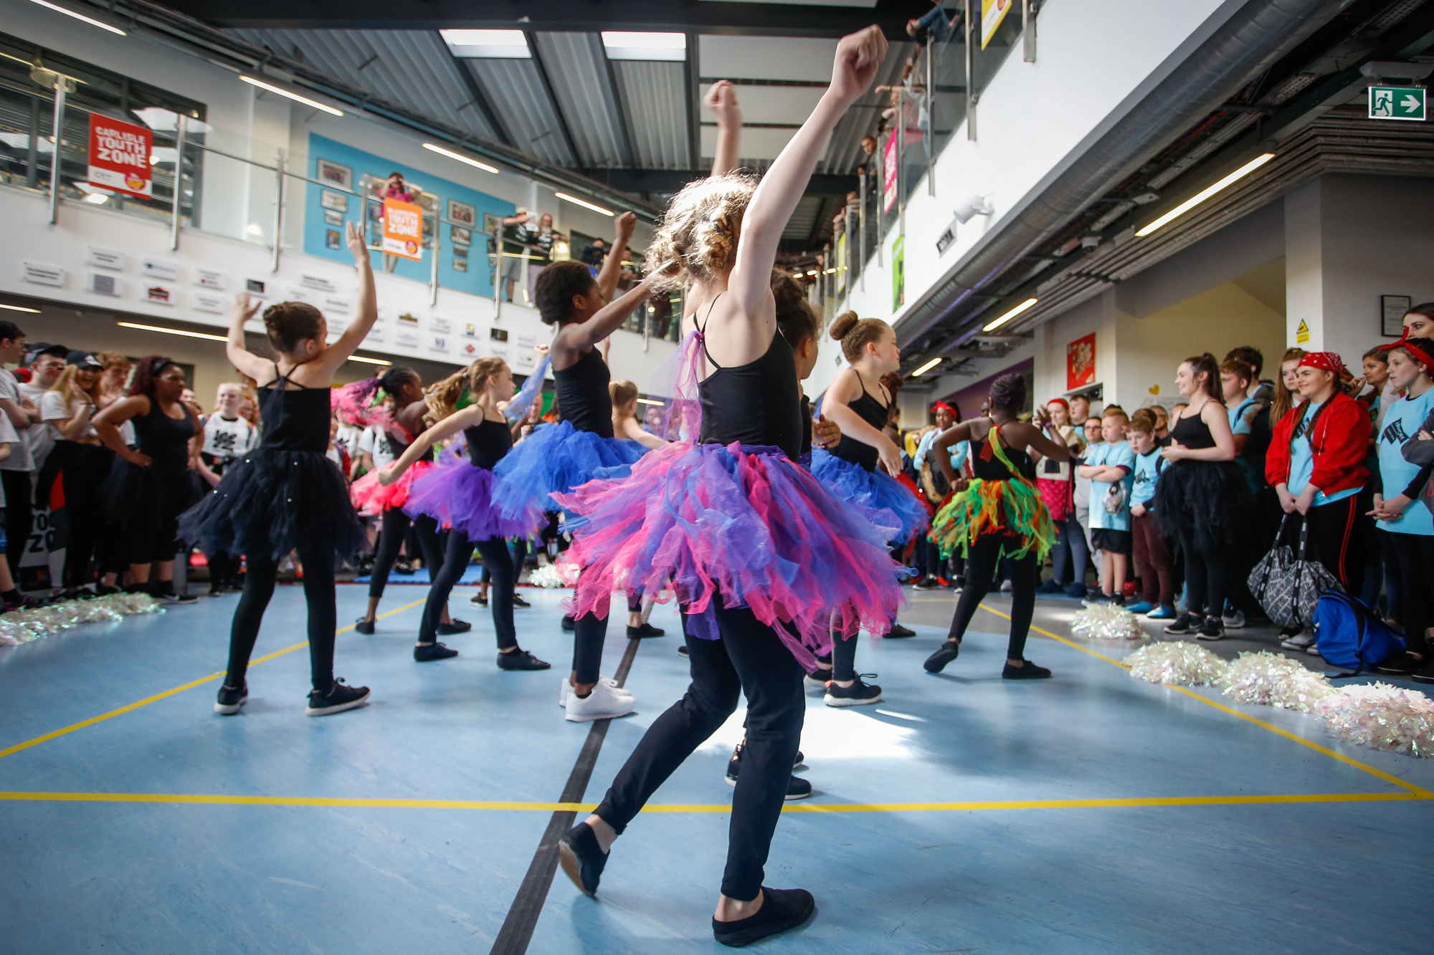

Job Purpose:

To raise the profile of Future Youth Zone amongst key stakeholders in the region through the development and implementation of a comprehensive communications and marketing strategy. You will be responsible for developing, managing and maintaining all communications and marketing activities within the Youth Zone to enhance visibility, build support and increase our effectiveness. In particular, you will
- Raise awareness of the Youth Zone amongst the whole community including young people, partners, funders and potential patrons/ donors
- Engage with young people, Future team and different stakeholders to really understand and be able to convey Future’s offer and ensure it aligns with local and national priorities
- Portray a positive image of young people, their achievements, development, voice, contribution etc.
- Produce high quality, creative and modern communications that really captivates the target audience and reflect Future’s brand values
Barking and Dagenham Youth Zone, named “Future” by local young people, is the first Youth Zone in London opened by the national charity, OnSide in May 2019. This is an exciting and unique opportunity to join the delivery team and play your part in history, shaping opportunities for London’s young people and supporting full time Youth Workers and Youth Work Managers.
Future, like all OnSide Youth Zone’s, exists to give young people, particularly those who are disadvantaged, somewhere to go, something to do and someone to talk to. Each Youth Zone is open 7 days a week, at weekends and during school holidays. The Youth Zone’s purpose is to help young people grow to be happy, healthy and successful adults.
Future’s state-of-the-art £6.15 million building on Parsloes Park, will provide young people with access to a range of activities, offering them the opportunity to try new things, meet new friends and gain support from friendly, warm and positive staff and volunteers. The facilities include a 3G pitch, a gym, sports hall, recreation area and dance, arts, music and media suites, with state-of-the-art facilities equipped for a wide range of sporting, artistic, cultural and general recreational activities and targeted services. To access a Youth Zone, young people aged 8 – 19 (or 25 with additional needs) simply pay 50p per visit and £5 per year membership.
Find out more by watching ….
- https://www.youtube.com/watch?v=Yb18h1TPRNE
- https://www.youtube.com/watch?v=Q3fFHKXV7ZQ
- https://www.youtube.com/watch?v=sZCMoDYEfTQ

Duties and Responsibilities - General
- Be a role model for young people and present a positive “can do” attitude
- Take personal responsibility for own actions
- Commit to a culture of continuous improvement
- Work within the performance framework of Future Youth Zone and OnSide
- Represent Future Youth Zone positively and effectively in all dealings with internal colleagues, and external partners
- Comply with all policies and procedures, with particular reference to safeguarding, codes of conduct health and safety and equality and diversity to ensure all activities are accessible
- Represent Future Youth Zone positively and effectively in all dealings with internal colleagues, and external partners
- To be alert to issues of safeguarding and child protection, ensuring the welfare and safety of Youth Zone members is promoted and safeguarded, and to report any child protection concerns to the designated Child Protection Officers using the safeguarding policies, procedures and practice (training to be provided)
- To assist with any promotional activities and visits that take place at the Youth Zone
- To actively promote the Youth Zone and positively contribute towards increasing Youth Zone membership
- To adhere to Future’s Youth Zone policies at all times, with particular reference to Health and Safety, Safeguarding and Equal Opportunities
Duties and Responsibilities – Detailed
The focus of the role is on outward communication, promoting Future to young people, parents and other stakeholders.
- With support from the OnSide Communications Team, develop the Youth Zone’s Communication, Marketing strategy and social media output
- To ensure the Youth Zones amazing offer is marketed to young people across a range of channels whilst keeping pace with the changing way young people engage with social media and other platforms. Ensure that Future remains we remains both relevant and effective in our communications to young people to drive participation and attendance.
- To liaise with Future’s staff team, young people and external stakeholders and communicate in an accurate and timely way. Use analytics to monitor and improve the effectiveness and reach of Future’s online presence
- Build positive relationships with key local and regional media to build Future’s profile and brand identity and generate positive coverage and dissemination of key messages
- Develop a comprehensive PR service and manage all media enquiries
- Plan, co-ordinate and produce a wide range of appropriate communications and marketing materials, both on and off-line, including research, developing content, writing, editing and designing
- Act as the guardian of Future’s brand, ensuring consistency of presentation and the further development and implementation of guidelines around visual identity. Promote good practice and train colleagues as appropriate
- Stay abreast of external communications trends, highlighting where new approaches might be beneficial and champion new technology. Learn new skills and then train and enthuse others to put these into practice
- Develop policies for communication and marketing in line with other relevant Youth Zone policies and ensure that they are consistently deployed
- Work with young people directly obtaining case studies and supporting young people to tell their own stories.
- Working with colleagues and with hands on support from the youth work delivery team, develop mechanisms to capture content from the young people and ensure the coherent communication of the brand
- Act as spokesperson on behalf of Future in the absence of the Chief Executive and Head of Youth Work
- Contribute to the organisation and management of events to promote and raise funds for the Youth Zone
- Work with OnSide and other Youth Zone Communications Managers to share best practice
- Support the fundraising team to liaise with communication and marketing counterparts in partner/donor organisations to support fundraising and development activity and maximise opportunities relating to these areas.
- Carry out any other reasonable duties as requested by management

Person Specification
Selection Criteria*  A = Application Form I = Interview T = Test/Personality Profile | Essential or Desirable | Method of Assessment
Experience
Extensive experience of delivering a comprehensive communication and marketing service | Essential | A & I
Comprehensive experience of development, communication and marketing strategies | Essential | A & I
Experience of web content development and website management | Essential | A & I
Extensive experience of working within a mixed office environment as the sole communication/marketing expert | Desirable | A & I
Extensive experience of using varied IT systems in digital communications | Essential | A & I
Varied and extensive experience of planning and delivering communication and marketing plans in line with organisational objectives and aims | Essential | A & I
Extensive experience of PR and delivering publicity at a local level | Essential | A, I & T
Advising and communicating to colleagues, partners and third parties on digital communications | Desirable | A & I
Experience of building relationships with senior stakeholders | Essential | A & I
Event management and organisation | Desirable | A & I
Project and budget management experience | Desirable | A & I
Educational / Vocational Qualifications
A relevant professional qualification | Essential | A
GCSE or equivalent literacy and numeracy | Essential | A
Member of CIPR or CIM | Desirable | A
Skills
Creative and innovative approach to planning communications delivery | Essential | A & I
Excellent ability to design and deliver digital communication plans that reflect Future’s core objectives | Essential | A
Thorough and accurate with excellent attention to detail | Essential | A & I
Ability to work under own initiative and work collaboratively | Essential | A & I
Excellent written and oral communications skills and an ability to establish good professional relationships with varied stakeholders | Essential | A & I
Ability to handle a varied workload, react quickly, meet deadlines and prioritise tasks | Desirable | A & I
Sound IT skills | Essential | A & I
Knowledge
Familiar with all the latest social media applications and how to effectively utilise them for organisational development | Essential | A & I
Strong understanding of digital communications developing social media output | Essential | A & I
Knowledge of range of relevant systems e.g. PR Max; Mail Chimp; Hoot Suite | Essential | A & I
Understanding of what makes marketing and communications effective for different audiences | Essential | A & I
Special Requirements
A willingness to work unsociable hours when required | Essential | A & I
DBS clearance and committed to Safeguarding children | Essential | A & I
The ability and willingness to travel to events in the region and beyond | Essential | A & I
*Selection criteria for guidance only, alternative methods may be used to assist the selection process

The strength of the OnSide Network of Youth Zone is the diversity of its people, we place huge value on different people doing things in different ways and we welcome applications from what might be considered none traditional backgrounds. The one thing we all have in common is our desire to raise the aspirations of young people across the country.

