Role Profile
Job title | Head of Education | Salary: | Up to £40,000 (depending on experience)
Reporting to: | Chief Executive | Holidays: | 33 days including bank holidays. To be taken during school holidays.
Location: | Future, Barking and Dagenham Youth Zone | Hours: | Full time (40 hours per week)  Fixed Term Contract – min 12 months
Key Relationships: | Board of Trustees, Chief Executive, Local Authority, Head Teachers, School Pastoral Support Staff, External Funders, External Programme or Activity Providers, Future Youth Zone Colleagues, Parents/Carers and Young People,
Key Dates and Application: | Closing date: 9am on 25th November 2020  Shortlisting: 26th November 2020  First Interview: 2nd December 2020  Second Interview: 4th December 2020  To apply please send a fully up to date CV of no more than two pages and a Cover Letter to recruitment@futureyouthzone.org  In your cover letter please include the following information:  In your cover letter, please provide the following information:  - Confirmation you are eligible to work in the UK;  - Details of your current or most recent remuneration package and your notice period;  - Any reasonable adjustments we can make to assist you in your application or the selection process;  - Reasons why you are suited to the role.

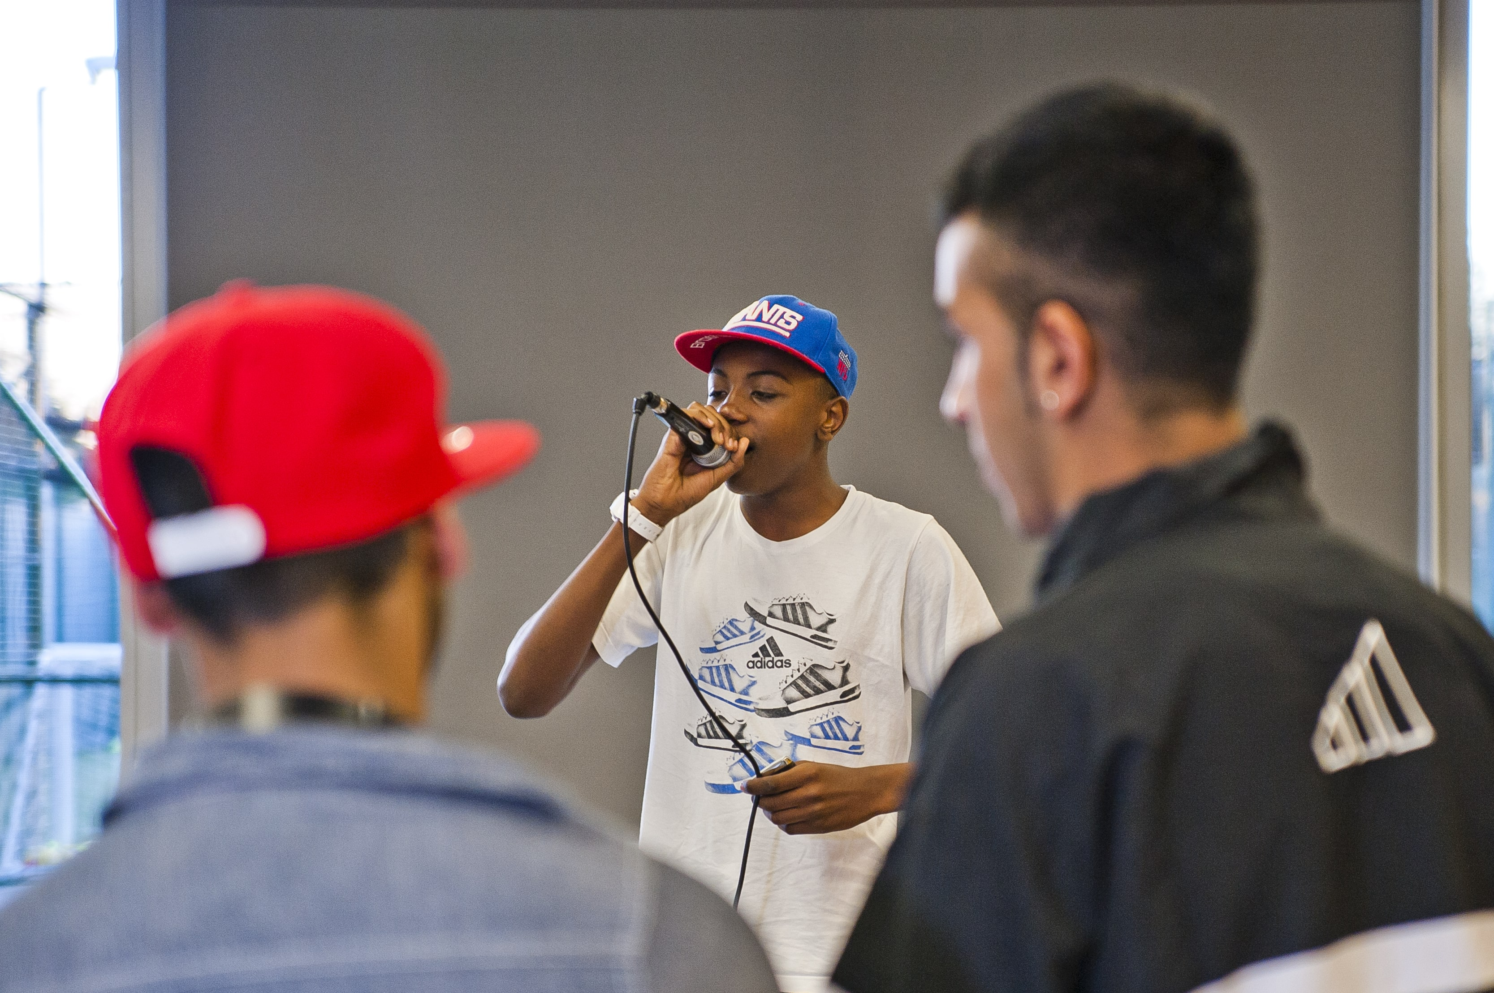
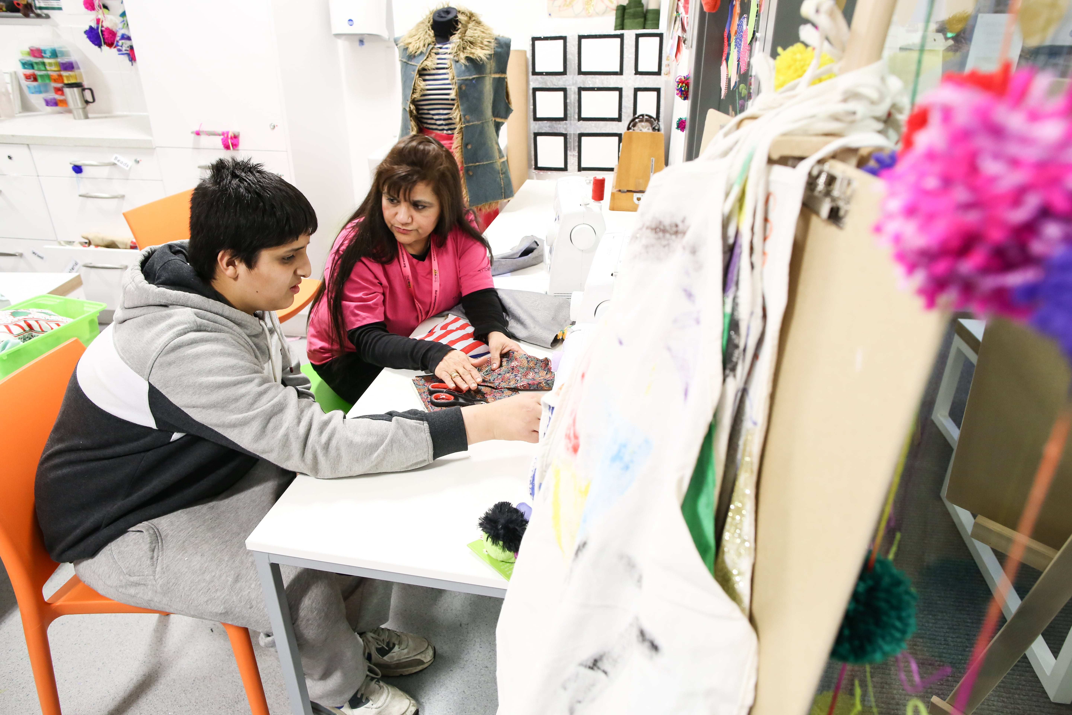
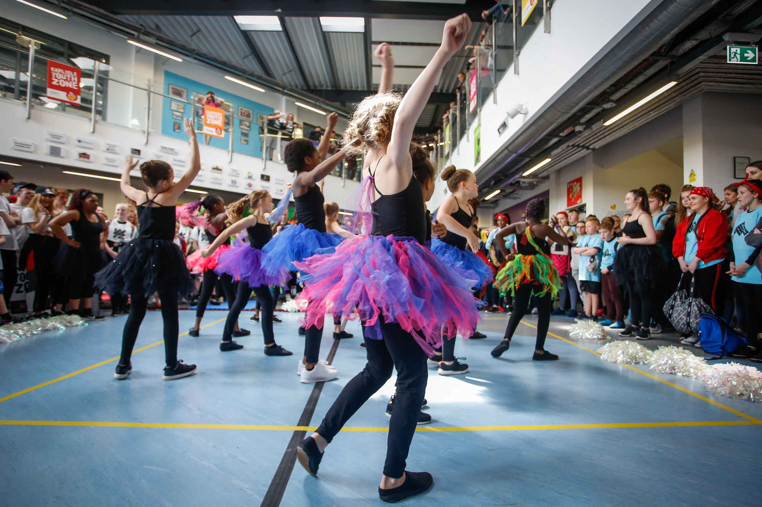

Job Purpose:

This is an exciting opportunity to lead on the development of new areas of work that will extend our support for children and young people in Barking and Dagenham. We are seeking someone who can combine a passion for supporting children and young people from vulnerable backgrounds with skills in contract management. As a starting point you will be leading and managing the delivery on two specific projects (see below) but your innovation and creativity will set the parameters for future ways to utilise our resources during the daytime for the benefit of children and young people.
- Complementary Education Provision
Working closely with Schools and the Local Authority you will lead a new complementary education programme that will support young people to be confident, independent and ambitious about their futures. The short programmes will focus support for specific groups of young people in mainstream education and will be successful in igniting the passion and imagination of participants. You will lead on all aspects of designing and implementing the programme and commit to continuous improvement to ensure positive outcomes for young people.
- Baby Zone
Did you know that a child’s development score at 22 months is the most accurate predictor of educational outcomes by the age of 26? And that children growing up in the poorest families in England are six times more likely to experience language delay at aged 5 than those growing up in the most well-off households?
We have developed a new model for supporting parents and babies to connect and learn together which we believe will have a positive impact on children and young people as they develop. We have tested it and now we want to develop this provision in Barking and Dagenham to be sustainable in the long term.
Your role will be to work with our delivery partner and internal Youth Zone team to ensure Baby Zone is successfully delivered and funding is secured to achieve longer term sustainability.

Future Youth Zone:
Barking and Dagenham Youth Zone, named ‘Future’ by local young people, is the first Youth Zone in London opened by the national charity, OnSide in May 2019. This is an exciting and unique opportunity to join our committed and passionate team and play your part in history, shaping opportunities for young people and helping to grow our charity and expand our services.
Future Youth Zone exists to give young people, particularly those who are disadvantaged, somewhere to go, something to do and someone to talk to. Each Youth Zone is open 7 days a week, at weekends and during school holidays. The Youth Zone’s purpose is to help young people grow to be happy, healthy and successful adults.
Future’s state-of-the-art £6.15 million building on Parsloes Park, provides young people with access to a range of activities, offering them the opportunity to try new things, meet new friends and gain support from friendly, warm and positive staff and volunteers. The facilities include a 3G pitch, a gym, sports hall, recreation area and dance, arts, music and media suites, with state-of-the-art facilities equipped for a wide range of sporting, artistic, cultural and general recreational activities and targeted services. The Youth Zone supports young people like Monique, Owen and Bola to grow and develop.

Duties and Responsibilities - General
- Be a role model for young people and present a positive “can do” attitude.
- Take personal responsibility for own actions.
- Commit to a culture of continuous improvement.
- Work within the performance framework of Future Youth Zone and OnSide.
- Represent Future Youth Zone positively and effectively in all dealings with internal colleagues, and external partners.
- Comply with all policies and procedures, with particular reference to safeguarding, codes of conduct health and safety and equality and diversity to ensure all activities are accessible.
- Represent Future Youth Zone positively and effectively in all dealings with internal colleagues, and external partners.
- To be alert to issues of safeguarding and child protection, ensuring the welfare and safety of Youth Zone members is promoted and safeguarded, and to report any child protection concerns to the designated Child Protection Officers using the safeguarding policies, procedures and practice (training to be provided).
- To assist with any promotional activities and visits that take place at the Youth Zone.
- To actively promote the Youth Zone and positively contribute towards increasing Youth Zone membership.
Duties and Responsibilities – Detailed
- Ensure that all programmes are advertised in a timely manner and are recruited to capacity.
- Manage and lead colleagues to ensure that delivery of sessions and activities are fun, impactful and work towards the development of children and young people.
- Work with funders and potential funders to ensure that they understand the impact of the programmes being delivered.
- Network with school leaders and representatives from the local authority to ensure our programmes are relevant and meeting the needs of children and young people in the borough.
- Budget effectively for all programmes ensuring they are fully cost recoverable.
- In collaboration with delivery staff, ensure programmes are innovative and developmental.
- Lead on monitoring and evaluation of programmes and present outcomes to both internal and external stakeholders.
- Communicate progress made by participants to all stakeholders on a regular basis.
- Develop and implement policies needed for the successful delivery of all programmes.
- To be credible and tactical, but willing to get your hands dirty - some days you could be presenting strategy to a room of top tier CEOs, or speaking to senior funders in government, other days you might end support delivery of services.
- To be comfortable to do things differently. We believe that change is positive and by doing things differently we are more likely to find ways that will further support children and young people.
- Be an active member of the Youth Zone’s management team and help to lead on achieving strategic goals of the charity.
- Carry out any other reasonable duties as requested by management

Person Specification
Selection Criteria*  A = Application Form I = Interview T = Test/Personality Profile | Essential or Desirable | Method of Assessment
Experience
Experience of successfully leading projects or programmes with young people from vulnerable groups. | Essential | A & I
Establishing and implementing behaviour management policies to support young people and staff members. | Essential | A & I
Supportive management and leadership of delivery staff members. | Essential | A & I
Able to effectively manage partnerships and external programme and activity provider relationships. | Essential | A & I
Experience of communicating effectively with stakeholders to provide updates on progress. | Essential | A & I
Starting programmes and projects from idea through to successful implementation. | Essential | A & I
Experience of building relationships with senior stakeholders | Essential | A & I
Writing funding bids and proposals. | Desirable | A & I
Project and budget management experience | Desirable | A & I
Educational / Vocational Qualifications
A relevant professional qualification (Youth Work or Teaching) | Essential | A
GCSE or equivalent literacy and numeracy | Essential | A
Skills
Proactive and able to make decisions confidently | Essential | A & I
Comfortable with flexibility and ambiguity | Essential | A & I
Thorough and accurate with excellent attention to detail | Essential | A & I
Ability to work under own initiative and work collaboratively | Essential | A & I
Excellent written and oral communications skills and an ability to establish good professional relationships with varied stakeholders | Essential | A & I
Ability to handle a varied workload, react quickly, meet deadlines and prioritise tasks | Desirable | A & I
Sound IT skills | Essential | A & I
Knowledge
Knowledge of monitoring and evaluation tools and how these can be incorporated into projects to demonstrate impact. | Essential | A & I
Understanding of safeguarding children and young people and contextual safeguarding. | Essential | A & I
Special Requirements
A willingness to work unsociable hours when required | Essential | A & I
DBS clearance and committed to Safeguarding children | Essential | A & I
The ability and willingness to travel to events in the region and beyond | Essential | A & I
*Selection criteria for guidance only, alternative methods may be used to assist the selection process
Future is committed to the safeguarding of young people. In accordance with our Child Protection and Safeguarding procedures, this position requires a enhanced DBS check.
The strength of OnSide Youth Zones comes from the diversity of the people within our vibrant network. We are proud that our Youth Zone teams reflect the communities they serve, and we value people working together from a range of different backgrounds locally and nationally, and with different experiences, all with a shared passion for boosting the aspirations of young people across the country. Diversity brings innovation, fresh ideas and creativity, and we actively strive to create a culture that is truly inclusive and fair for all and where everyone in the team can be themselves and thrive.

