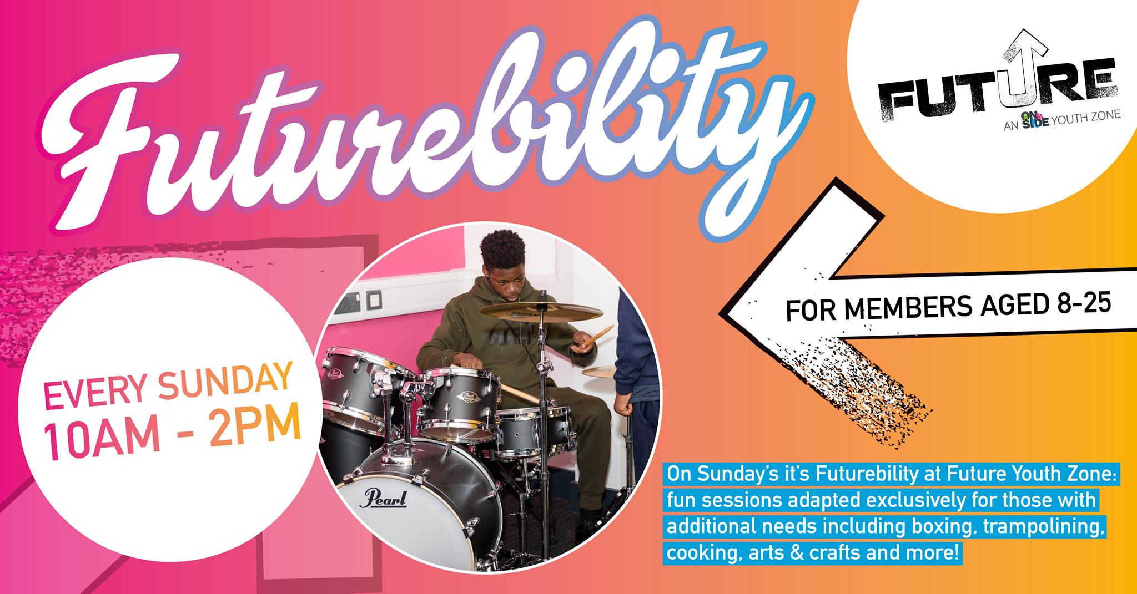

**Location: Future Youth Zone  
Suggested Time Commitment:** 1 session per week**(although there is flexibility in this)**



* Enjoys meeting and engaging with people from a wide range of backgrounds
* Is empathetic to the needs of young people with additional support needs
* Shares the same values of **Future**
* Is a strong communicator with the ability to (or the willingness to learn to) adapt their styles of communication
* Has the ability to adapt activities to suit the needs of the young person and can think on their feet
* Patient and calm under pressure
* Is committed to promoting inclusivity, accessibility, and making a positive impact on the lives of young people
* Is happy to undertake further training as necessary   
  ------------------------------------------------------------------------------------------------------------------------------------------------------

Please note that for this role you need to be at least 18 years of age and be prepared to undergo an enhanced DBS check.

**WE’RE LOOKING FOR SOMEONE WHO:**

You will gain new skills and develop existing ones whilst making a significant contribution to the lives of the young people with additional support needs. You will become part of our team; our young people and their families/guardians will become a part of a positive support network. You will enhance your CV whilst also being there as a positive role model for many of our young people. The benefits really are endless!

**WHAT ARE THE BENEFITS TO YOU AND OUR YOUNG PEOPLE?**

* Supporting young people with additional support needs whilst they participate in different activities around the youth zone. This can include sports, arts, music, cooking and everything in between!
* Actively engaging with, spending time with and supporting young people with additional support needs to foster a positive, supportive enviroment
* Encouraging young people to participate and enjoy their sessions
* Building positive relationships with young people across the youth zone
* Working collaboratively with the Inclusion Coordinator and other members of staff to support the delivery and accessibility of sessions
* Acting as a positive role model for young people
* Promoting an inclusive culture where all young people are listened to, valued, and cared for, with particular reference to the wishes of young people with additional support needs

**WHAT CAN YOU EXPECT TO BE DOING?**

Our Volunteer Inclusion Youth Workers help us provide extra support to young people with additional needs/disabilities while they’re attending universal sessions. The sessions give young people the opportunity to engage with their peers in a range of dynamic and engaging activities allowing them to build their confidence, social skills and overall wellbeing.

**ABOUT THE ROLE**

**VOLUNTEER INCLUSION YOUTH WORKER**