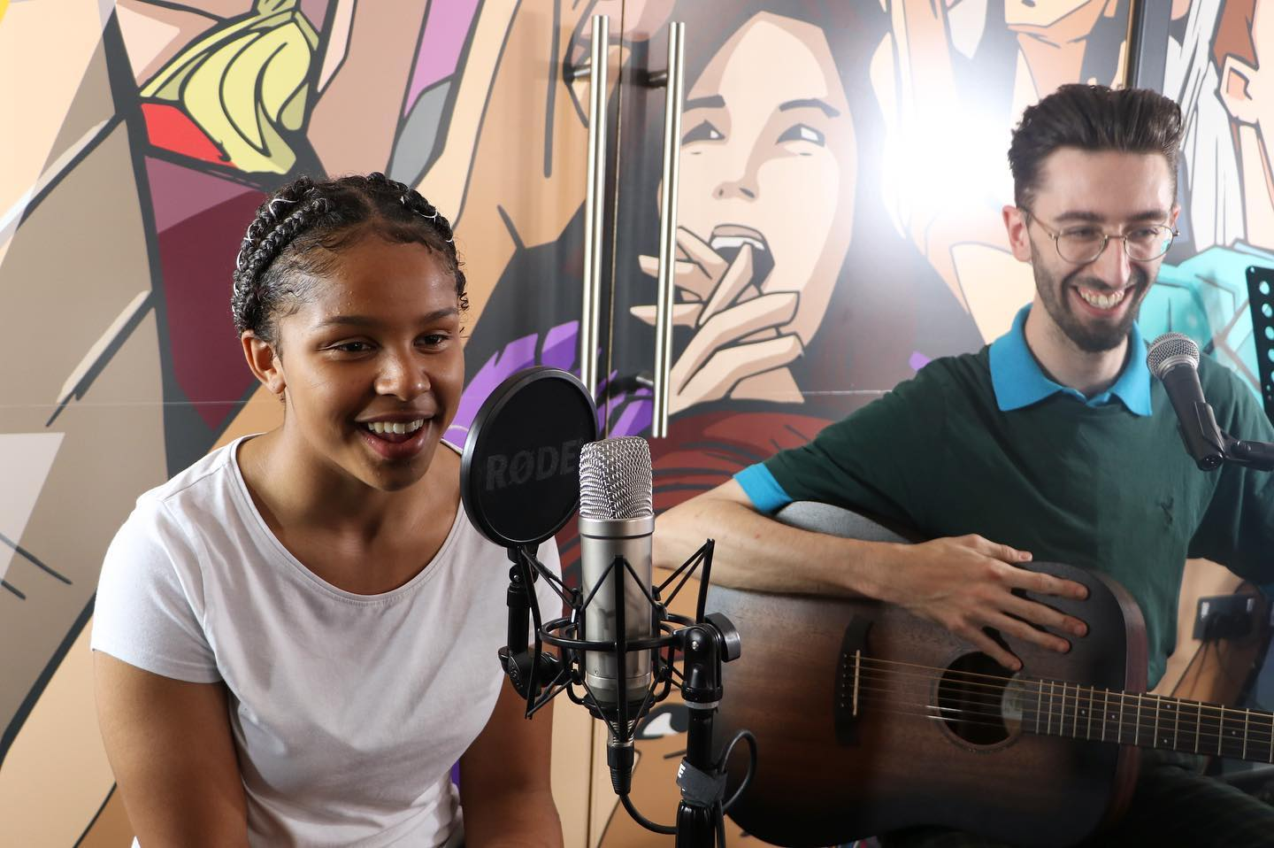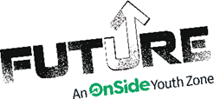

* Either helping to deliver sessions experimenting with different types of media (such as video editing, photography, podcasts) or delivering sessions that develop young people’s music skills (including playing instruments, recording and producing)
* Encouraging young people to participate and enjoy their sessions
* Building positive relationships with young people across the youth zone
* Working collaboratively with the Arts Coordinator and other members of staff to support the delivery of sessions
* Supporting young people with additional needs
* Acting as a positive role model for young people
* Promoting an inclusive culture where all young people are listened to, valued, and cared for

**WE’RE LOOKING FOR SOMEONE WHO:**

**WHAT ARE THE BENEFITS TO YOU AND OUR YOUNG PEOPLE?**

* Enjoys meeting and engaging with people from a wide range of backgrounds
* Is adaptable and happy to try new things
* Some experience in at least one area (i.e. playing an instrument or experience with recording) would be great but if you don’t have any, an active interest and for media and/or music will be more than enough!
* Shares the same values of **Future**
* Is committed to making a positive impact on the lives of young people   
  ------------------------------------------------------------------------------------------------------------------------------------------------------

Please note that for this role you need to be at least 18 years of age and be prepared to undergo an enhanced DBS check.

You will gain new skills and develop existing ones whilst making a significant contribution to the lives of the young people. You will become part of our team and our young people will have a great time. You will enhance your CV whilst also being there as a positive role model to many of our young people. The benefits really are endless!

**WHAT CAN YOU EXPECT TO BE DOING?**

Our Media and Music Youth Workers help us to deliver sessions that bring young people together to celebrate creativity through music and media. They support young people’s creative skills and encourage them to explore new ideas to build their confidence, social skills and overall wellbeing.

**ABOUT THE ROLE**

**VOLUNTEER MEDIA & MUSIC YOUTH WORKER**

**Location: Future Youth Zone  
Suggested Time Commitment: 1 session per week (although there is flexibility in this)**