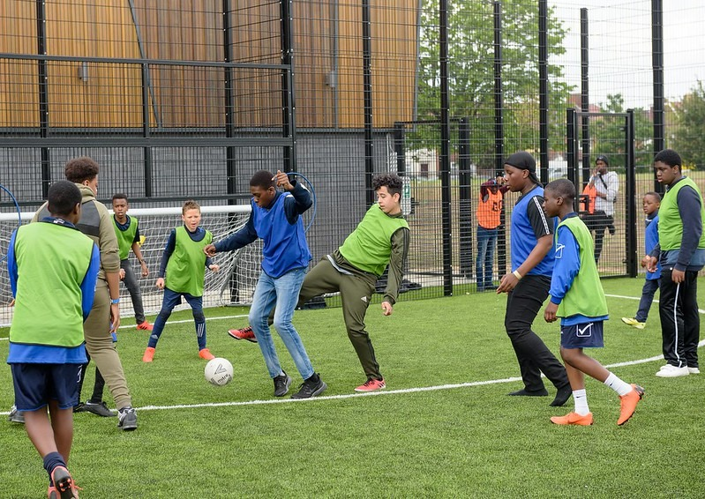



**VOLUNTEER SPORTS YOUTH WORKER**

* Enjoys meeting and engaging with people from a wide range of backgrounds
* Loves working within a team and getting involved in group activities
* Enjoys being active and partaking in physical activities
* Shares the same values of **Future**
* Is committed to making a positive impact on the lives of young people

------------------------------------------------------------------------------------------------------------------------------------------------------

Please note that for this role you need to be at least 18 years of age and be prepared to undergo an enhanced DBS check.

**WE’RE LOOKING FOR SOMEONE WHO:**

You will gain new skills and develop existing ones whilst making a significant contribution to the lives of the young people. You will become part of our team whilst our young people will gain a positive experience of sport and physical activity. You will enhance your CV whilst also being there as a positive role model to many of our young people. The benefits really are endless!

**WHAT ARE THE BENEFITS TO YOU AND OUR YOUNG PEOPLE?**

* Helping to deliver sports sessions including; basketball, football, badminton, tennis and more!
* Motivating young people to participate and enjoy their sessions
* Building positive relationships with young people across the youth zone
* Working collaboratively with the Sports Coordinator and other members of staff to support the delivery of sports sessions
* Supporting young people with additional needs
* Acting as a positive role model for young people
* Promoting an inclusive culture where all young people are listened to, valued, and cared for

**WHAT CAN YOU EXPECT TO BE DOING?**

Our Volunteer Sports Youth Workers help us to deliver sports sessions that bring young people together. These sessions enable young people to build their confidence, social skills and overall well-being through physical activity.

**ABOUT THE ROLE**

**Location: Future Youth Zone  
Suggested Time Commitment: 1 session per week (although there is flexibility in this)**