ROLE PROFILE

JOB TITLE: | Head of Baby Zone (Barking and Dagenham) | SALARY: | £32,000 - £36,000 (pro rata)
REPORTING TO: | CEO | HOLIDAYS: | 33 days including bank holidays
LOCATION: | Future Youth Zone, 201-225 Porters Avenue, Dagenham, RM 5YX | HOURS: | Part time – 16 – 24 hours per week
THE PERSON: | The Head of Baby Zone holds overall responsibility for ensuring the delivery of a quality and consistent Baby Zone offering in Croydon with 100+ babies, toddlers and their carers attending each week. They will be accountable for the effective development and delivery of Baby Zone offer, including developing local stakeholder relationships, exploring local funding opportunities and continuing to learn and refine the offer based on evidence and feedback from our families.
KEY RELATIONSHIPS: | CEO, Finance Manager, Head of Fundraising, Director of Babyzone UK, Head of Baby Zone in other Youth Zone locations, Facilities Manager and Operations and Customer Services Officers.

JOB PURPOSE:

Did you know that a child’s development score at 22 months is the most accurate predictor of educational outcomes by the age of 26? And that children growing up in the poorest families in England are six times more likely to experience language delay at aged 5 than those growing up in the most well-off households?
Because of that we have developed a new model for supporting parents and babies to connect and learn together which we believe will have a positive impact on children and young people as they develop. We have tested it and now you will be responsible for leading this provision in Barking and Dagenham and making sure it is sustainable for the long term.

CONTEXT OF THE POST:

Barking and Dagenham Youth Zone, named ‘Future’ by local young people, is the first Youth Zone in London opened by the national charity, OnSide in May 2019. This is an exciting and unique opportunity to join a small but growing, impactful fundraising team and play a critical part in shaping opportunities for East London’s young people and supporting a grass roots, committed, universal youth service.

Future, like all OnSide Youth Zones, exists to give young people, particularly those who are disadvantaged, somewhere to go, something to do and someone to talk to. The Youth Zone is open 7 days a week, at weekends and during school holidays. The Youth Zone’s purpose is to help young people grow to be happy, healthy and successful adults.

Future’s state-of-the-art £6.15 million building on Parsloes Park, provides young people with access to a range of activities, offering them the opportunity to try new things, meet new friends and gain support from friendly, warm and positive staff and volunteers. The facilities include a 3G pitch, a gym, sports hall, recreation area and dance, arts, music and media suites, with state-of-the-art facilities equipped for a wide range of sporting, artistic, cultural and general recreational activities and targeted services. The Youth Zone supports young people like Monique, Owen and Bola to grow and develop.

DUTIES AND RESPONSIBILITIES – DETAILED

- Responsible for working with any Future team that deliver Baby Zone activities plus external contractors to ensure a high quality and consistent Baby Zone offer is delivered in Barking and Dagenham every week
- To act as the key on-site point of contact for operational problem solving, risk management and safeguarding
- To own and build local stakeholder relationships e.g. council, other charities, local WOW delivery team to build on the success and sustainability of the offer
- Lead on Barking and Dagenham specific Baby Zone fundraising e.g. securing council grant support and exploring other grant opportunities and input into UK-wide fundraising efforts
- Lead on recruitment of local families using the Baby Zone UK recommended methods and continuously test and refine these approaches together with wider Baby Zone UK team
- Lead data collection and reporting including supporting any piloting or evaluation that takes place in Barking and Dagenham.
- Understand and manage Baby Zone budget in Barking and Dagenham
- Input into the development Baby Zone replicable toolkit working with the Director of Baby Zone UK and the Head of Baby Zone in other locations.
- To play an active part in the Baby Zone UK national management team and able to represent and advocate for Baby Zone in Barking and Dagenham and beyond.

DUTIES AND RESPONSIBILITIES - GENERAL

- Be a role model for young people and present a positive “can do” attitude.
- Take personal responsibility for own actions.
- Commit to a culture of continuous improvement.
- Work within the performance framework of Future Youth Zone and OnSide.
- Represent Future Youth Zone positively and effectively in all dealings with internal colleagues, and external partners.
- To be alert to issues of safeguarding and child protection, ensuring the welfare and safety of Youth Zone members is promoted and safeguarded, and to report any child protection concerns to the designated Child Protection Officers using the safeguarding policies, procedures and practice (training to be provided).
- To assist with any promotional activities and visits that take place at the Youth Zone.
- To adhere to Future Youth Zone policies at all times, with particular reference to Health and Safety, Safeguarding and Equal Opportunities

PERSON SPECIFICATION

Person Specification Selection Criteria*  A = Application Form, I = Interview, T = Assessment | Essential or Desirable | Method of Assessment
Experience
Substantial experience of working in the early years/charity sector at a national/pan-regional level | Essential | A & I
Substantial experience of building partnerships and stakeholder relationships | Essential | A & I
Significant experience of managing teams to deliver specific outcomes | Essential | A & I
A track record of successful project management | Essential | A, I, T
Experience of working in an agile and flexible way responding to the different needs of a growing or changing organisation | Essential | A, I, T
Experience of working through a staff team to deliver results | Essential | A, I & T
Experience of working within a team and prioritising work | Essential | A & I
Experience of managing and budgets | Essential | A, I & T
A track record of working with external funders | Desirable | A & I
Educational / Vocational Qualifications
GCSE or equivalent literacy and numeracy | Essential | A
Skills
Excellent communication skills, both verbal and written, relationship building, negotiation and interpersonal skills | Essential | A, I & T
Ability to relate to people and families from all backgrounds | Essential | A & I
Effective people management and coaching skills | Essential | A & I
Ability to both lead a team and work as a team member | Essential | A & I
Self-motivated and able to work to multiple deadlines, remaining calm under pressure | Essential | A & I
Strong organisational skills, with structured approach, ability to be flexible and responsive with a focus on results | Essential | A & I
Ability to be non-judgemental and open-minded | Essential | A & I
Ability to care about and be sensitive to individuals and the community | Essential | A & I
Is able to be flexible to meet the needs of families | Essential | A & I

*Selection criteria for guidance only, alternative methods may be used to assist the selection process

Future Youth Zone is committed to the safeguarding of young people. In accordance with our Child Protection and Safeguarding procedures, this position requires a enhanced DBS check.

The strength of OnSide Youth Zones comes from the diversity of the people within our vibrant network. We are proud that our Youth Zone teams reflect the communities they serve, and we value people working together from a range of different backgrounds locally and nationally, and with different experiences, all with a shared passion for boosting the aspirations of young people across the country. Diversity brings innovation, fresh ideas and creativity, and we actively strive to create a culture that is truly inclusive and fair for all and where everyone in the team can be themselves and thrive.
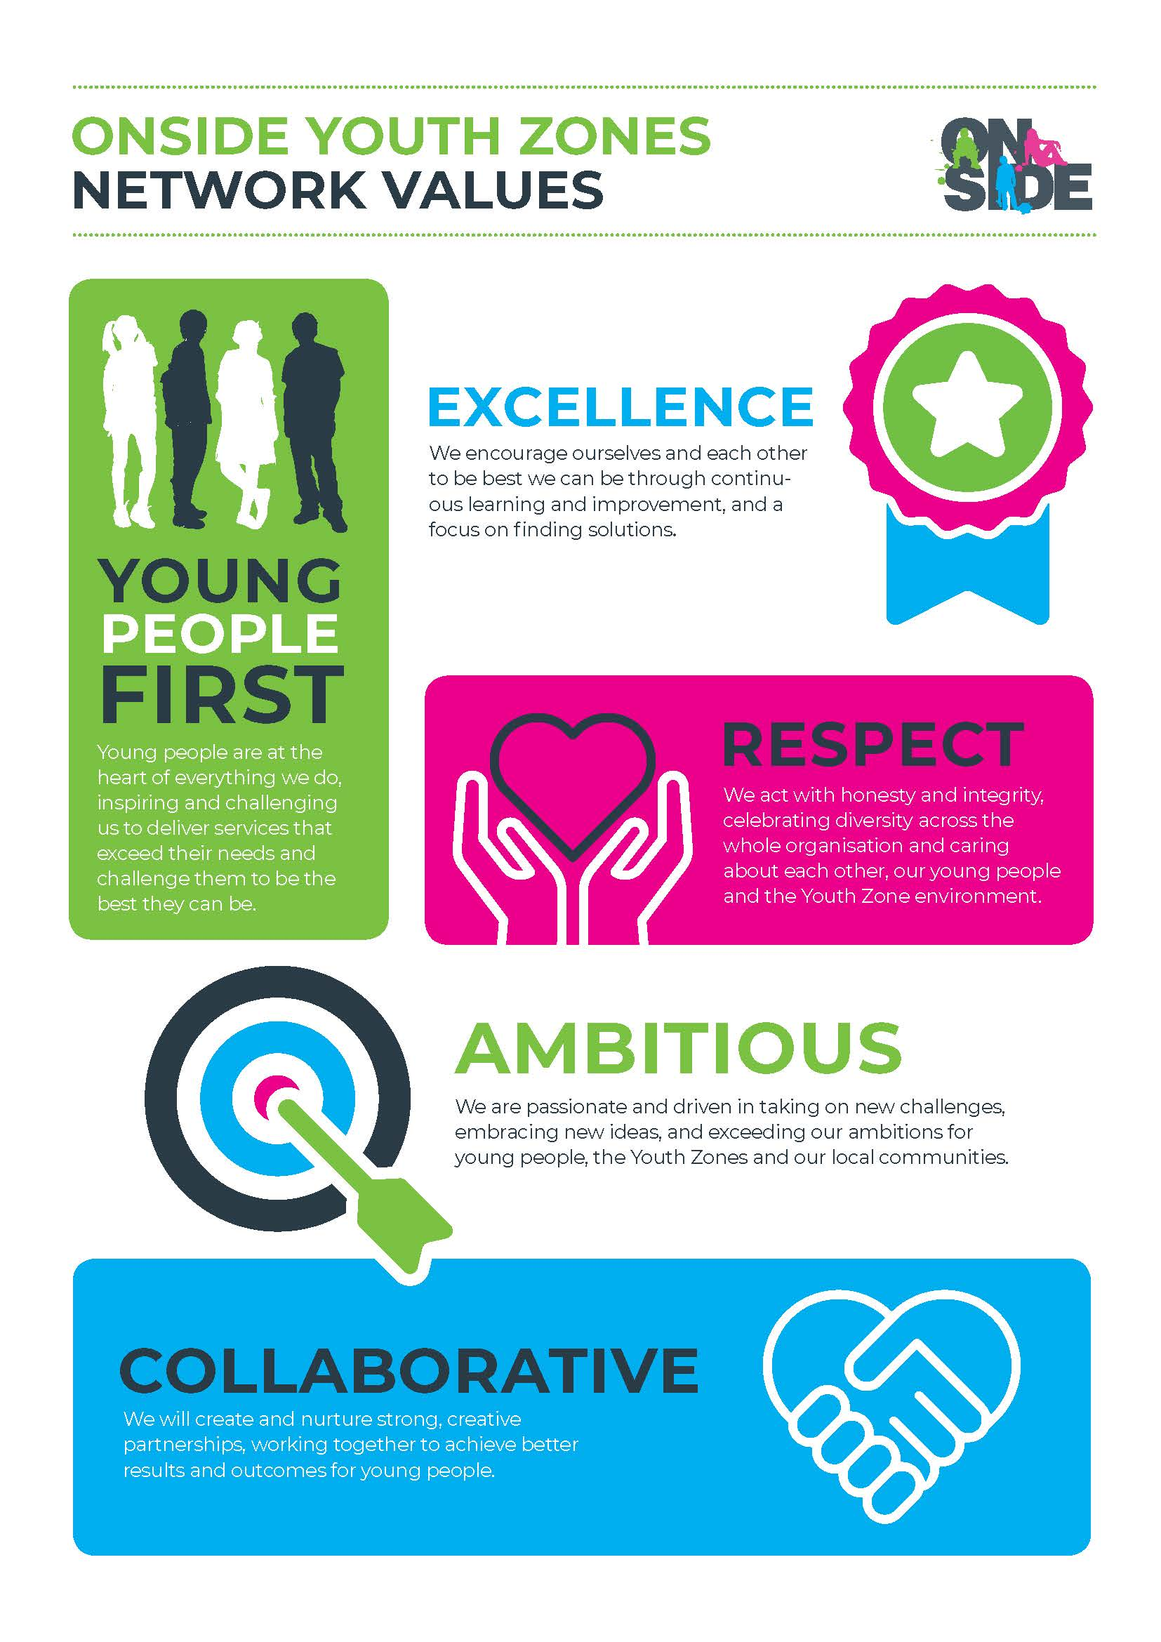
For information regarding how Future Youth Zone and OnSide Youth Zones process your data, please visit www.onsideyouthzones.org/applicant-privacy/

