Role Profile - Youth Worker – Health and Wellbeing
Job title | Health and Wellbeing Youth Worker | Salary: | £10.85 per hour (rising to £11.05 from April 2022)
Reporting to: | Youth Work Team Leader | Holidays: | 33 days including bank holidays (pro-rata)
Location: | Future Youth Zone | Hours: | Sessions available 7 days a week.
The Person: | You will be a Youth Worker committed to working young people and enjoy project an issue-based work with a range young people as much as you do from fun activities. Passionate about creating exciting and fun activities, leading gender specific work or possibly running health or beauty sessions (for all young people!)?
To Apply: | Please complete the sessional application form and email this to recruitment@futureyouthzone.org

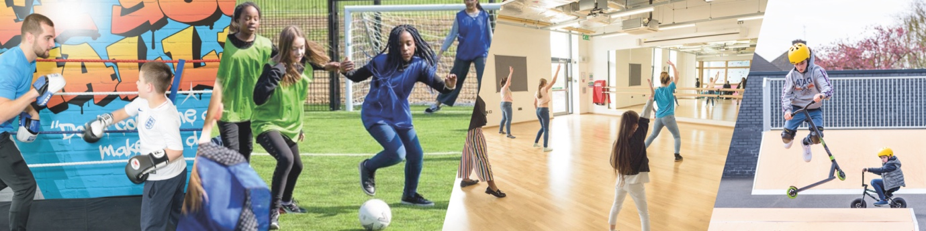

Job Purpose:

Our health and wellbeing work, alongside arts and sport are at the heart of Future’s offer to young people. Feedback from young people and experience from operational Youth Zones tells us that some young people, such as young women, wanted dedicated and safe spaces within their Youth Zone. Young people also tell us that all opportunities should be open to all young people. This role is based in the health and well-being room, which is also equipped with a hair and beauty salon. Here you will work with all young people to provide a wide range of opportunities from informal education sessions, health projects and the more traditional health and beauty activities.

About Future Youth Zone:
Barking and Dagenham Youth Zone, named “Future” by local young people, was the first Youth Zone in London to be opened by the national charity, OnSide in Spring 2019. This is an exciting and unique opportunity to join the delivery team and play your part in shaping opportunities for London’s young people and supporting full time Youth Workers and Youth Work Managers.

Future, like all OnSide Youth Zones, exists to give young people, particularly those who are disadvantaged, somewhere to go, something to do and someone to talk to. Each Youth Zone is open 7 days a week, at weekends and during school holidays, with the purpose of supporting young people to become happy, healthy and successful adults.

Future’s state-of-the-art £6.5 million building on Parsloes Park provides young people with access to a range of activities, offering them the opportunity to try new things, meet new friends and gain support from friendly, warm and positive staff and volunteers. The facilities include a 3G pitch, a gym, sports hall, recreation area and dance, arts, music and media suites, with facilities equipped for a wide range of sporting, artistic, cultural and general recreational activities and targeted services. To access a Youth Zone, young people aged 8 – 19 (or 25 with additional needs) simply pay 50p per visit and £5 per year membership.

Find out more by watching this video of Monique, Owen and Bola talking about how the Youth Zone has changed their lives.

Duties and Responsibilities - General
- Be a role model for young people and present a positive “can do” attitude
- Take personal responsibility for own actions
- Commit to a culture of continuous improvement
- Work within the performance framework of Future Youth Zone and OnSide
- Represent Future Youth Zone positively and effectively in all dealings with internal colleagues, and external partners
- Comply with all policies and procedures, with particular reference to safeguarding, codes of conduct health and safety and equality and diversity to ensure all activities are accessible
- Represent Future Youth Zone positively and effectively in all dealings with internal colleagues, and external partners
- To be alert to issues of safeguarding and child protection, ensuring the welfare and safety of Youth Zone members is promoted and safeguarded, and to report any child protection concerns to the designated Child Protection Officers using the safeguarding policies, procedures and practice (training to be provided)
- To assist with any promotional activities and visits that take place at the Youth Zone
- To actively promote the Youth Zone and positively contribute towards increasing Youth Zone membership
- To adhere to Future Youth Zone policies at all times, with particular reference to Health and Safety, Safeguarding and Equal Opportunities

Duties and Responsibilities – Detailed

- Together with the Junior Club Manager, Senior Club Manager and Rec Lead, develop and implement a programme that is exciting, challenging and ever changing
- To deliver targeted sessions to young people, ranging from informal education sessions to hair and beauty
- To deliver gender specific work
- The role is 100% face to face delivery with young people
- To work directly with young people to develop their social skills
- To directly deliver a high-quality programme of activities that is exciting, safe, varied, innovative, developmental and directly responds to the diverse needs, concerns and interests of the members
- To have great energy and establish positive relationships with young people, the wider youth work team and visitors to the Youth Zone
- To respond to the needs of young people through activities and project work
- To support and motivate volunteers
- To work flexibly to ensure the needs of the members are met, including disadvantaged young people and those with disabilities or additional needs
- To ensure that the members maintain a high standard of behaviour and discipline during sessions by making the area a hub of activity and fun
- To ensure the participation of young people in activities and that their ideas contribute fully in the delivery of activities in a safe way
- To assist with any promotional activities and visits that take place at the Youth Zone
- To actively promote the Youth Zone and positively contribute towards increasing Youth Zone membership
- To promote and safeguard the welfare of young people at all times
- To be able to think on your feet and deliver an activity with minimal equipment
- Ability to enthuse others, including staff, volunteers and young people
- To make the environment fun and the place young people want to be
- To be an active member of the team and operate in line with the values and principles of Future Youth Zone
- Carry out any other reasonable duties as requested by management

Person Specification
Selection Criteria*  A = Application Form I = Interview T = Test/Personality Profile | Essential or Desirable | Method of Assessment
Experience
Experience of working with groups of young people aged 8 to 19, or up to aged 25 with a disability | Essential | A & I
Experience of working with young people from diverse backgrounds and with challenging needs | Essential | A & I
Experience of working with young women | Essential | A & I
Experience of working with LGBTQ+ young people
Experience of delivering targeted sessions | Essential | A & I
Experience of delivering events and displays | Desirable | A & I
Experience of working with young people with additional needs and disabilities | Desirable | A & I
Experience of team working and working alongside volunteers | Essential | A & I
Qualifications
Level 2 Youth Work qualification or equivalent | Desirable | A
Skills
Ability to deliver high quality targeted programmes with children and young people who face social exclusion, disadvantage and disaffection and manage such a group | Essential | A & I
Practical skills in health and beauty or skills to deliver health and well-being projects | Essential | A & I
Able to work as part of a team and under own initiative | Essential | A & I
Able to plan and evaluate programs of activity, including production of session plans and evaluations | Essential | A & I
Able to communicate effectively with young people, parents, team members and members of the public | Essential | A & I
Ability to engage and build positive relationships with young people including disengaged and disadvantaged young people | Essential | A & I
Knowledge
Understand the principles of working with children and young people, the issues affecting their lives and knowledge of their needs | Desirable | A & I
Knowledge of health and safety, diversity awareness and safeguarding best practice | Essential | A & I
Basic knowledge of arts pathways | Desirable | A & I
Special Requirements
A willingness to work unsociable hours | Essential | A & I
The ability and willingness to travel to events in the region and beyond | Essential | A & I
Enhanced DBS clearance and commitment to Safeguarding children | Essential | A & I

The strength of the OnSide Network of Future Youth Zone is the diversity of its people; we place huge value on different people doing things in different ways and we welcome applications from what might be considered non-traditional backgrounds. The one thing we all have in common is our desire to raise the aspirations of young people across the country. Future Youth Zone are committed to safeguarding and promoting the welfare of children, young people and vulnerable groups.

For information regarding how OnSide Youth Zones processes your data, please click
here: www.futureyouthzone.org/privacy-policy/

