Role Profile: Youth Worker – Rec Area
Job title |  | Youth Worker – Rec Area | Salary | £11.05 an hour
Reporting to |  | Rec Area Lead / Senior or Junior Club Manager | Holidays | 33 days including bank holidays (pro rata)
Location |  | Future Youth Zone | Hours | Monday & Tuesday 3:45pm – 9:15pm, Wednesday 3:45pm – 8:15pm, Saturday 3:45pm – 10:15pm, Sunday 2:45pm – 7:15pm
The Person | The ‘rec area’ is the heart of the Youth Zone: we are looking for a Youth Worker committed to creating positive relationships with young people, ideally with an ice breaker, game or challenge for every occasion, and passionate about creating a fun, positive and energetic environment.
Key Relationships | Core Management team, Youth Work Managers, OnSide, External Stakeholders, Young People and Parents.
 | To apply please complete the sessional application form, which can be found on our website and send to recruitment@futureyouthzone.org
Future Youth Zone are committed to safeguarding and promoting the welfare of children, young people and vulnerable groups. This post is subject to an enhanced DBS check. Pre-employment checks will be required for this role.
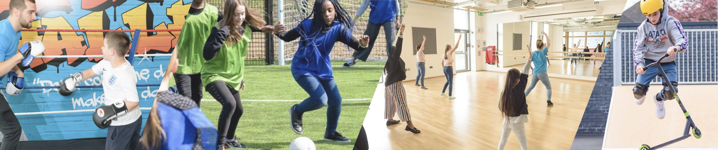

Job Purpose

The Rec is an open access area, which is at the very centre of the Youth Zone and where every young person spends time at some point during their visit! The role requires you to make the space welcoming and inspiring. You will be key in ensuring young people and their voices feature in the programme with activities designed around their needs, facilitating the successes of Future to young people and the wider community through our Rec offer.

Context of the post
Barking and Dagenham Youth Zone, named “Future” by local young people, was the first Youth Zone in London opened by the national charity, OnSide in Spring 2019. This is an exciting and unique opportunity to join the delivery team and play your part in shaping opportunities for London’s young people and supporting full time Youth Workers and Youth Work Managers.

The Future, like all OnSide Youth Zones, exists to give young people, particularly those who are disadvantaged, somewhere to go, something to do and someone to talk to. Each Youth Zone is open 7 days a week, at weekends and during school holidays, with the purpose of supporting young people to become happy, healthy and successful adults.

Future’s state-of-the-art £6.5 million building on Parsloes Park provides young people with access to a range of activities, offering them the opportunity to try new things, meet new friends and gain support from friendly, warm and positive staff and volunteers. The facilities include a 3G pitch, a gym, sports hall, recreation area and dance, arts, music and media suites, with facilities equipped for a wide range of sporting, artistic, cultural and general recreational activities and targeted services. To access a Youth Zone, young people aged 8 – 19 (or 25 with additional needs) simply pay 50p per visit and £5 per year membership.

The Youth Zone supports young people like Monique, Owen and Bola to grow and develop. Check out the linked video!

Key Duties and Responsibilities
- Together with the Junior and Senor Club Managers and the Arts Coordinator, to develop, implement and deliver a high-quality programme of activities that are exciting, challenging, developmental and ever-changing, and that directly respond to the diverse needs and interests of young people.
- To introduce young people to the various forms of the media, film and radio arts industry, such as the production of radio shows, photography and the creation of short films.
- Through media, film and radio, to work with young people to ensure their participation, develop their social skills and ideas, and create opportunities to showcase their talents and artistic skills.
- To encourage participation in arts activities, particularly by young people who would not usually participate or are new to such activities.
- To be alert to issues of safeguarding and child protection, ensuring the welfare and safety of young people is promoted and safeguarded, and to report any child protection concerns to the designated Safeguarding Leads, using the Youth Zone’s safeguarding policies, procedures and practices (training will be provided).
- To work flexibly and inclusively to ensure the needs of all young people are met, particularly those with disabilities or additional needs.
- To ensure young people maintain a high standard of behaviour and discipline during sessions by making the area a hub of activity and fun.
- To actively promote and positively represent the Youth Zone, contributing towards increasing membership and assisting with promotional activities and visits to the Youth Zone.
- To comply with all policies and procedures, with particular reference to safeguarding, codes of conduct, health and safety, and equality and diversity, to ensure all activities are safe, accessible and inclusive.
- To be an active member of the team, carrying out any other reasonable duties as requested by the management team, and operating in line with the values and principles of the Youth Zone.

Person Specification
Applicants must demonstrate in their application form that they currently have the experience and use the skills outlined below or have used them previously in employment, education, training, volunteering etc.

Selection Criteria  A = Application Form I = Interview AS = Assessment | Essential or Desirable | Method of Assessment
Experience
Experience of working with groups of young people aged 8 to 19, and / or up to aged 25 with a disability | Essential | A, I & AS
Experience of working with young people from diverse backgrounds and with challenging needs and/or additional needs and disabilities | Essential | A, I & AS
Experience of delivering performing arts sessions | Essential | A, I & AS
Experience of team working and working alongside volunteers | Essential | A & I
Experience of delivering events / displays and performances | Desirable | A & I
Qualifications
Relevant media & film, photography or radio or production qualification(s) | Essential | A & I
Level 2 Youth Work Qualification | Desirable | A
Skills
Ability to deliver high quality performing arts programme with children and young people who face social exclusion, disadvantage and disaffection and manage such a group | Essential | A & I
Ability to teach and coach in Film, Media and or Radio | Essential | A, I & AS
Able to plan and evaluate programs of activity including production of session plans and evaluations | Essential | A, I & AS
Able to communicate effectively with young people, parents, team members and members of the public | Essential | A & I
Ability to engage and build positive relationships with young people including disengaged and disadvantaged young people | Essential | A & I
Knowledge
Knowledge of health and safety, diversity awareness and safeguarding best practice | Essential | A & I
Understand the principles of working with children and young people, the issues affecting their lives and knowledge of their needs | Desirable | A & I
Basic knowledge of arts pathways | Desirable | A & I
Aptitude
Positive, ‘can do’ approach | Essential | I & AS
Initiative and commitment to continuous improvement | Essential | I & AS
Special Requirements
A willingness to work unsociable hours | Essential | A & I
Ability and willingness to travel to events in the region and beyond | Essential | A & I
DBS clearance and committed to Safeguarding children | Essential | A & I

The strength of the OnSide Network of Youth Zone is the diversity of its people, we place huge value on different people doing things in different ways and we welcome applications from what might be considered non-traditional backgrounds. The one thing we all have in common is our desire to raise the aspirations of young people across the country.

