Role Profile



Youth Worker Creative Arts

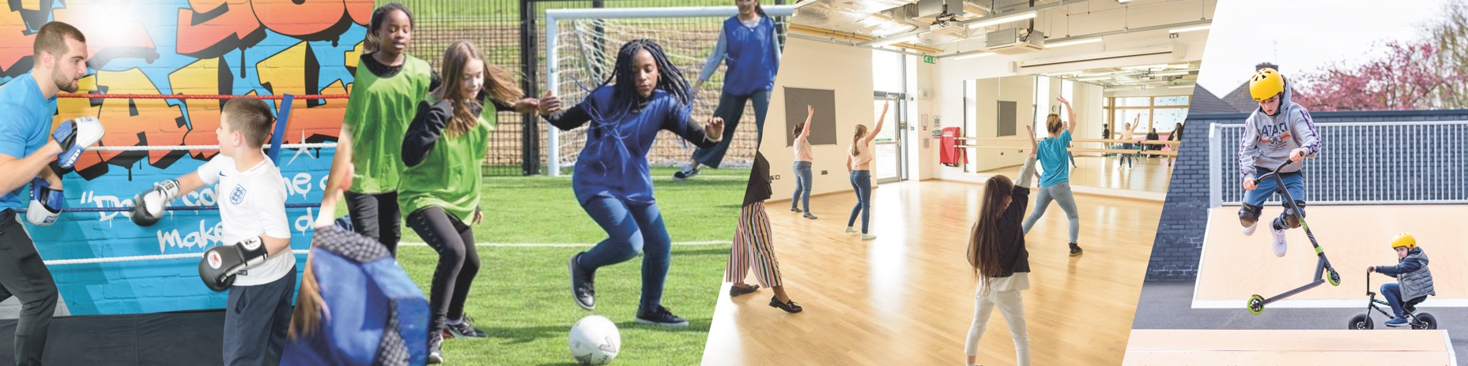

JOB TITLE: | Youth Worker, Creative Arts (Art Room) | SALARY: | London's Real Living Wage currently, £13.15 an hour
REPORTING TO: | Arts Co-ordinator | HOLIDAYS: | 34 days including bank holidays and a day off on your birthday – Pro Rata
LOCATION: | Future Youth Zone, 201-225 Porters Avenue, Dagenham, RM9 5YX | HOURS: | Monday 3:45pm – 9:15pm, Thursday 3:45pm – 9:15pm, Friday 3:45pm – 10:15pm, Saturday 3:45pm – 10:15pm
THE PERSON: | You will be a Youth Worker committed to creative arts and developing positive relationships with young people, this could be from messy play, screen printing and jewellery making to clay, fashion, and painting. Arts youth workers are a key part of the Youth Zone, working directly with young people creating a relaxing and welcoming environment for all young people regardless of experience or ability.
KEY RELATIONSHIPS:  KEY DATES: | Young people and parents, Arts Co-ordinator, Head of Youth Work, Senior Club Manager, Junior Club Manager, Inclusion Manager, Volunteers, Sports Co-ordinator and Rec Lead  Closing date: Monday 2nd June Interviews will be held during the day or in the evening of the week beginning Monday 7th June  To apply please complete the sessional application form, which can be found on our website and send to recruitment@futureyouthzone.org
Future Youth Zone are committed to safeguarding and promoting the welfare of
children, young people and vulnerable groups. This post is subject to an enhanced DBS check. Pre-employment checks will be required for this role.

JOB PURPOSE:

The Arts offer here at Future is wide-ranging and includes visual arts, music, media, dance, drama and more. You will be key in ensuring young people and their voices feature in the programme with activities designed around their needs, facilitating the successes of Future to young people and the wider community through our Arts offer. We are looking for a talented Youth Worker to join our team with expertise and experience in creating, delivering and engaging young people through music via one of activities and sessions all the way through to projects, competitions and showcases.

CONTEXT OF THE POST:

Future was the first Youth Zone in London opened by the national charity, OnSide in Spring 2019.
Future, like all OnSide Youth Zones, exists to give young people, particularly those who are disadvantaged, somewhere to go, something to do and someone to talk to. Each Youth Zone is open 7 days a week, at weekends and during school holidays, with the purpose of supporting young people to become happy, healthy and successful adults.

The Youth Zone supports young people like Monique, Owen and Bola to grow and develop.


DUTIES AND RESPONSIBILITIES

  - To work directly with young people to support the planning and delivery of safe, fun and structured arts sessions within the Youth Zone which are progressive and reflect the needs of young people.
  - To contribute to an arts programme that is high quality and meets the needs of young people, including young people with additional needs and disabilities and young people who typically don’t engage in arts.
  - To deliver art sessions including printmaking, crafts, fashion, textiles and painting to young people, using art as a medium of communication.
  - To support an arts programme that contributes to the wider youth work agenda, supporting the development of young people.
  - To confidently manage and establish positive relationships with groups of children and young people.
  - To complete all monitoring information required for impact measures, to encourage feedback from young people taking part in activities, and to share this with the staff team regularly.
  - To work with young people from a range of backgrounds and with a range of needs.
  - Effectively communicate at all levels, orally and in writing
  - To work alongside other team members and provide guidance and support to young leaders and volunteers.
  - To undertake and attend regular training and development sessions and events where required.
  - To deliver leadership awards to young people and co-ordinate volunteering opportunities in arts activities
  - To contribute towards the Youth Zones programme of arts events, performances and exhibitions
  - To encourage attendance and participation in arts activities, particularly by young people who do not usually participate in art.
  - To assist in identifying talented young people and encouraging further development via several different opportunities.
  - To maintain current knowledge of relevant National Governing Body programmes, local and national arts initiatives policies and practices
  - To promote cultural cohesion and inclusion and proactively challenge any prejudice and discrimination.
  - Carry out any other reasonable duties as requested by management.
  - Be committed to a culture of continuous improvement.
  - Work within the performance framework of Future Youth Zone and OnSide.
  - To be alert to issues of safeguarding and child protection, ensuring the welfare and safety of Youth Zone members is promoted and safeguarded, and to report any causes of concerns to the Session Lead or Safeguarding team (training will be provided).
  - To assist with any promotional activities and visits that take place at the Youth Zone.
  - To comply with all policies and procedures, with reference to safeguarding, codes of conduct, health and safety, and equality and diversity, to ensure all activities are safe, accessible, and inclusive.

Person Specification
Applicants must demonstrate in their application form that they currently have the experience and use the skills outlined below or have used them previously in employment, education, training, volunteering etc.

Person Specification

Selection Criteria*  A = Application Form I = Interview AS = Assessment | Essential or Desirable | Method of Assessment
Experience
Experience in leading/supporting and working with groups of young people 8-12 and/or young people aged 13-19 | Essential | A & I
Experience working with young people from diverse backgrounds and with challenging needs | Essential | A & I
Experience in delivering a wide range of arts sessions | Essential | A & I
Experience in delivering events / displays and performances | Desirable | A & I
Experience working with young people with additional needs and disabilities | Desirable | A & I
Experience in pottery-making | Desirable | A & I
Experience of teamwork working and alongside volunteers | Essential | A & I
Qualifications
Level 2 Arts qualification or equivalent | Desirable | A
Additional Arts Qualifications | Desirable | A
Skills
Ability to deliver high-quality arts programmes to children and young people who face social exclusion, disadvantage and disaffection and manage such a group | Essential | A & I
Able to work as part of a team and under own initiative | Essential | A & I
Able to plan and evaluate programs of activity including the production of session plans and evaluations | Essential | A & I
Able to communicate effectively with young people, parents, team members and members of the public.  Able to work under own initiative | Essential | A & I
Able to deliver within an equal opportunities framework | Essential | A & I
Ability to engage and build positive relationships with young people including disengaged and disadvantaged young people | Essential | A & I
Ability to coach, encourage, motivate and provide reliable support to children and young people | Essential | A & I
Knowledge
Understand the principles of working with children and young people, the issues affecting their lives and knowledge of their needs | Desirable | A & I
Knowledge of health and safety, diversity awareness and safeguarding best practice | Essential | A & I
Good knowledge of arts pathways/career avenues | Desirable | A & I
Special Requirements
A willingness to work unsociable hours and cover events, holidays and staff absence | Essential | A & I
DBS clearance and committed to Safeguarding children | Essential | A & I

*Selection criteria for guidance only, alternative methods may be used to assist the selection process

THE OTHER BITS…

The strength of the OnSide Network of Youth Zone is the diversity of its people, we place huge value on different people doing things in different ways and we welcome applications from what might be considered non-traditional backgrounds. The one thing we all have in common is our desire to raise the aspirations of young people across the country.
For information regarding how Future Youth Zone and OnSide Youth Zones process your data, please visit www.futureyouthzone.org/privacy-policy/

OUR VALUES AND STAFF BENEFITS:

