Role Profile



Sports Youth Worker - Boxing & Martial Arts

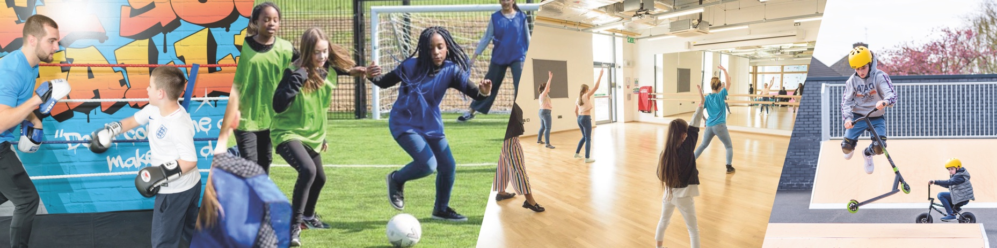

JOB TITLE: | Youth Sports Worker – Boxing and Martial Arts | SALARY: | London Real Living Wage currently £13.85 an hour
REPORTING TO: | Sports Coordinator | HOLIDAYS: | 34 days including bank holidays and a day off on your birthday – Pro Rata
LOCATION: | Future Youth Zone, 201-225 Porters Avenue, Dagenham, RM9 5YX | HOURS: | Monday 3:45pm – 9:15pm, Tuesday 3:45pm – 9:15pm, Saturday 9:45am – 2:15pm, Saturday 3:45pm – 10:15pm, Sunday 2:45pm - 7:15pm
THE PERSON: | Do you love Sport and Fitness and are you passionate about the role martial arts and/or boxing can play in changing young people’s lives? Utilising our boxing ring and training room you will work with young people using the medium to challenge their own fitness in their bodies but also in their minds. You will create a space that will enable young people to have someone to talk to making the space a place that facilitates conversations with young people to give them someone to talk to about what is going on in their lives, exploring their hopes, fears, and dreams. This is a great opportunity for someone looking to progress and develop their career in Youth Work or transition into the sector.
KEY RELATIONSHIPS:  KEY DATES: | Young people and parents, Sports Co-ordinator, Head of Youth Work, Senior Club Manager, Junior Club Manager, Inclusion Manager, Volunteers, Arts Co-ordinator and Rec Lead  Closing date: xxxxx Interviews will be held during the day or in the evening of the week beginning xxxxxxx  To apply please complete the sessional application form, which can be found on our website and send it to recruitment@futureyouthzone.org

Future Youth Zone is committed to safeguarding and promoting the welfare of children, young people and vulnerable groups. This post is subject to an enhanced DBS check. Pre-employment checks will be required for this role.

JOB PURPOSE:

Sports alongside the Arts and Youth Work is at the heart of the Youth Zone’s offer to young people. As a Youth Worker in the Sports Team, you will ensure young people have access to an exciting and engaging programme of adventurous activities. You will provide supervision and advice to young people, and support and guide the Youth Zone’s staff and volunteers.
Within the Sports Team, we are looking for talented sports and fitness coaches to become part of a team with a wide range of skills, who are also passionate about working with young people. Ideally, you will have experience, or one or more coaching qualifications, such as a level 2 National Governing Body Award in either boxing, kickboxing or other martial arts.

CONTEXT OF THE POST:

Future was the first Youth Zone in London opened by the national charity, OnSide in Spring 2019.
Future, like all OnSide Youth Zones, exists to give young people, particularly those who are disadvantaged, somewhere to go, something to do and someone to talk to. Each Youth Zone is open 7 days a week, at weekends and during school holidays, with the purpose of supporting young people to become happy, healthy and successful adults.

The Youth Zone supports young people like Monique, Owen and Bola to grow and develop.

DUTIES AND RESPONSIBILITIES

- Together with the Sports Coordinator, plan, develop and implement a comprehensive boxing / martial arts area programme for young people, enabling them to build their confidence, social skills and overall wellbeing
- Coordinate and deliver the programme to young people
- Ensure continuous development of the programme, developing and expanding to meet the changing needs of our members
- Carry out inductions for new users and provide supervision in the boxing / martial arts area, promoting best practices and safety standards
- Ensure the highest standards of health and safety are maintained in the boxing arena and monitor safety practices whilst working.
- Ensure that all equipment necessary for each session is fit for purpose and adheres to safety standards
- Carry out and log daily, weekly and monthly checks, reporting any defects or faults to the Sports Coordinator. Carry out remedial action where appropriate
- To assist in the completion of risk assessments/accident reports and to report to the relevant Session Manager / Lead any accidents/incidents that require attention.
- To deliver accredited awards, motivate, encourage and support young people to participate fully in the boxing /martial arts area offer
- Keep up to date on policies or procedures required for safety in the boxing / martial arts area
- To promote cultural cohesion and inclusion and proactively challenge any prejudice and discrimination
- Carry out any other reasonable duties as requested by management
- Be committed to a culture of continuous improvement.
- Work within the performance framework of Future Youth Zone and OnSide.
- To be alert to issues of safeguarding and child protection, ensuring the welfare and safety of Youth Zone members is promoted and safeguarded, and to report any causes of concerns to the Session Lead or Safeguarding team (training will be provided).
- To assist with any promotional activities and visits that take place at the Youth Zone.
- To comply with all policies and procedures, with reference to safeguarding, codes of conduct, health and safety, and equality and diversity, to ensure all activities are safe, accessible and inclusive.

Person Specification
Applicants must demonstrate in their application form that they currently have the experience and use the skills outlined below or have used them previously in employment, education, training, volunteering etc.

Person Specification

Selection Criteria*  A = Application Form I = Interview T = Test/Personality Profile | Essential or Desirable | Method of Assessment
Experience
Experience of working with groups of young people aged 8 to 19, or up to age 25 with a disability | Essential | A & I
Experience of working with young people from diverse backgrounds and with additional needs | Essential | A & I
Experience of Boxing / MMA | Essential | A & I
Experience of conducting boxing equipment safety checks | Desirable | A & I
Experience of working with young people with additional needs and disabilities | Desirable | A & I
Experience of delivering Boxing / martial arts sessions | Desirable | A & I
Qualifications
Level 2 coaching qualification e.g.: ABA Boxing, Kick Boxing Level 2, other disciplines | Essential | A
First Aid qualification | Desirable | A
Skills
Ability to deliver high quality Boxing / martial arts activities with young people | Essential | A & I
Able to work as part of a team and under own initiative | Essential | A & I
Able to manage challenging behaviour | Essential | A & I
Able to communicate effectively with young people, parents, team members and members of the public | Essential | A & I
Ability to engage and build positive relationships with young people including disengaged and disadvantaged young people | Essential | A & I
Ability to coach, encourage, motivate and provide reliable support to young people | Essential | A & I
Knowledge
Understand the principles of working with young people, the issues affecting their lives and knowledge of their needs | Desirable | A & I
Knowledge of health and safety and best practice in a Boxing / martial arts environment | Essential | A & I
Special Requirements
A willingness to work unsociable hours and cover events, holidays and staff absence | Essential | A & I
DBS clearance and committed to Safeguarding children | Essential | A & I

*Selection criteria for guidance only, alternative methods may be used to assist the selection process

THE OTHER BITS…

The strength of the OnSide Network of Youth Zone is the diversity of its people, we place huge value on different people doing things in different ways and we welcome applications from what might be considered non-traditional backgrounds. The one thing we all have in common is our desire to raise the aspirations of young people across the country.
For information regarding how Future Youth Zone and OnSide Youth Zones process your data, please visit www.futureyouthzone.org/privacy-policy/

OUR VALUES AND STAFF BENEFITS:

