Role Profile



Youth Counsellor

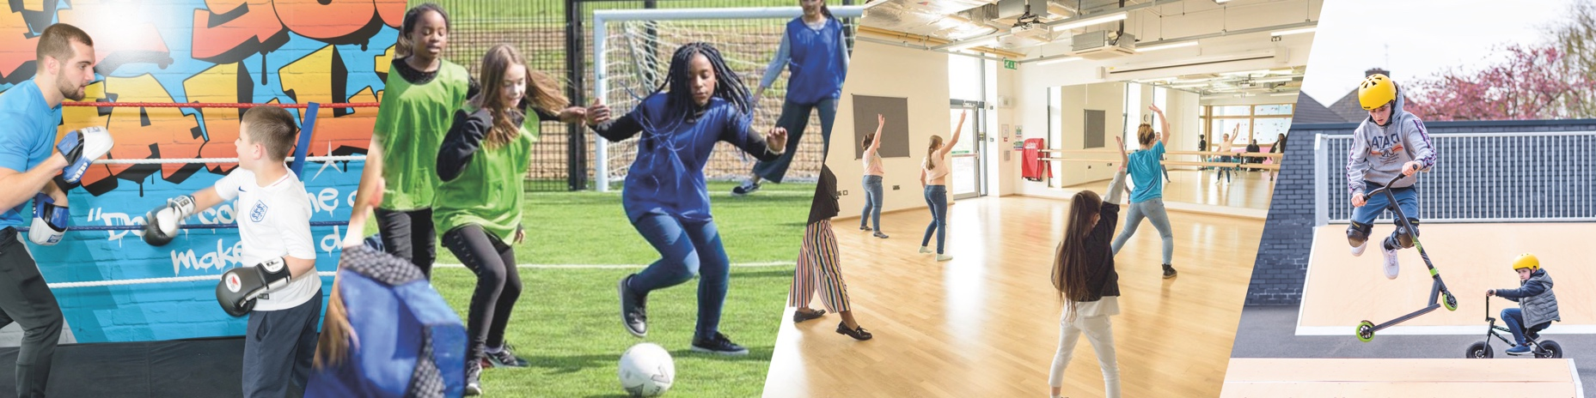

JOB TITLE: | Youth Counsellor | SALARY: | £30 an hour
REPORTING TO: | Head of Youth Work/Clinical supervisor | HOLIDAYS: | Term Time Only
LOCATION: | Future Youth Zone, 201-225 Porters Avenue, Dagenham, RM9 5YX | HOURS: | 6 hours per week.  Evenings and weekends.
THE PERSON: | We’re seeking two dedicated and empathetic Youth Counsellors with knowledge and experience of working with and supporting young people’s wellbeing.
KEY RELATIONSHIPS: | Senior and Junior Club Manager, Inclusion Manager, Head of Youth Work, Youth Zone Team Members, Young People, Parents/Carers, and the wider community.

JOB PURPOSE:

Our mission is to offer a secure and inclusive space for young people to seek support for their wellbeing within the trusted Youth Zone environment. This is an exciting opportunity to help establish an innovative, community-based counselling service for children and young people in the Barking and Dagenham area.

We are looking for enthusiastic Counsellors to become part of a team who are passionate about working with young people.

CONTEXT OF THE POST:

Barking and Dagenham Youth Zone, named as Future by young people, was opened in May 2019. The Youth Zone is an independent Charity, but we are proud to be part of the growing OnSide Network whereby we have adopted a set of principles that guide our work with young people.

Our universal offer is focussed around a state-of-the-art, multimillion pound facility that is purpose built and remains dedicated to young people. We work with young people aged from 8-19 (up to 25 with additional needs) and offer an array of activities for young people to get involved in. Our services are affordable for young people who can access the provision for just a £5 annual membership and 50p entry fee. Whilst our building and activities provide a hook for young people to initially engage with us, the relationships they develop with our team of Youth Workers ensures they return night after night. We pride ourselves on being open when young people need us the most, during evenings and weekends, whenever schools are closed.

Since we opened in May 2019 the Youth Zone has had over 17,500 young people sign up as members of which around 65% are male and 35% are female. At times during our opening year 1,600 young people were visiting the Youth Zone every week, making it a go to destination for the next generation up until the Covid-10 Pandemic period. During that period, we were able to continue to support young people using new and innovative forms of engagement, whilst we also extended our support to the wider community when they needed it the most.
Since then we have returned to a full offer and are still open 7 days a week for young people however this has come with a set of new challenges wrapped in increased living costs. Our team continue to provide a home from home for young people.

DUTIES AND RESPONSIBILITIES – DETAILED

- Provide drop-in and one-on-one counselling sessions tailored to the emotional, behavioural, and developmental needs of young people.
- Build trusting relationships with young people to foster resilience, self-esteem, and emotional wellbeing through consistent support and active engagement.
- Collaborate with youth workers to design and deliver engaging activities that promote mental health, personal growth, and social inclusion.
- Use creative approaches such as art-based activities, interactive games, or digital tools to foster engagement within both the Youth Zone space and the therapy room.
- Support youth workers to facilitate workshops topics such as emotional regulation, conflict resolution, identity, and healthy relationships.
- Identify and respond to safeguarding concerns in line with club policies, ensuring timely intervention and appropriate referrals.
- Where necessary, liaise with families, schools, and external agencies to ensure holistic and coordinated support for each young person.
- Maintain accurate records of sessions, incidents, and progress notes, contributing to monitoring, evaluation, and reporting requirements.
- Attend regular clinical supervision and line management meetings.

DUTIES AND RESPONSIBILITIES - GENERAL
- Be a role model for young people and present a positive “can do” attitude.
- Take personal responsibility for own actions.
- Commit to a culture of continuous improvement.
- Work within the performance framework of Future Youth Zone and OnSide.
- Represent Future Youth Zone positively and effectively in all dealings with internal colleagues, and external partners.
- To be alert to issues of safeguarding and child protection, ensuring the welfare and safety of Youth Zone members is promoted and safeguarded, and to report any child protection concerns to the designated Safeguarding Officer using the safeguarding policies, procedures and practice (training to be provided).
- To adhere to Future Youth Zone policies at all times, with particular reference to Health and Safety, Safeguarding and Equal Opportunities

Person Specification

Selection Criteria*  A = Application Form I = Interview T = Test/Personality Profile | Essential or Desirable | Method of Assessment
Experience
Experience working with young people in community or educational settings. | Essential | A & I
Experience of working with young people from diverse backgrounds and with challenging needs | Essential | A & I
Experience in youth work or group facilitation. | Desirable | A & I
Qualifications
Recognised qualification in counselling/psychotherapy/ creative therapies (Level 6 or above preferred). | Essential | A & I
Hold individual BACP /UKCP (or equivalent) registration with a proven commitment to continuing learning and professional development. | Essential | A & I
Skills
Ability to empathise with needs of young people from a range of communities and backgrounds and a working knowledge of the social issues that affect young people and impact upon their mental health and well-being. | Essential | A & I
Excellent interpersonal and communication skills, both written and verbal. Ability to work as part of a team from different theoretical backgrounds and identify with organisational goals. | Essential | A & I
Creative approach to engagement (e.g., using art, music, sport, or digital media). | Desirable | A & I
Knowledge
Demonstrates a strong understanding of child and adolescent development with a sensitivity to the unique characteristics and needs of a wide range of young people, including LBGTQ+, neurodivergent or young people with additional needs. | Essential | A & I
Demonstrates adherence to counselling ethical guidelines, upholding confidentiality, professionalism, and prioritising client welfare throughout practice to ensure safe, ethical, and effective support for young people. | Essential | A & I
Knowledge of and experience of organisational safeguarding standards by participating in safeguarding training sessions and implementing clear reporting procedures to protect children, young people, and vulnerable adults. | Essential | A & I
Knowledge of local services and referral pathways. | Desirable | A & I
Special Requirements
Ability to work flexibly, including evenings and weekends. | Essential | A & I
Commitment to equality, diversity, and inclusion. | Essential | A & I
Enhanced DBS clearance and commitment to Safeguarding children | Essential | A & I
Willingness to undertake ongoing professional development. | Essential | A & I

THE OTHER BITS…

Future Youth Zone is committed to the safeguarding of young people. In accordance with our Child Protection and Safeguarding procedures, this position requires an enhanced DBS check.
The strength of OnSide Youth Zones comes from the diversity of the people within our vibrant network. We are proud that our Youth Zone teams reflect the communities they serve, and we value people working together from a range of different backgrounds locally and nationally, and with different experiences, all with a shared passion for boosting the aspirations of young people across the country. Diversity brings innovation, fresh ideas and creativity, and we actively strive to create a culture that is truly inclusive and fair for all and where everyone in the team can be themselves and thrive.
For information regarding how Future Youth Zone and OnSide Youth Zones process your data, please visit www.futureyouthzone.org/privacy-policy/

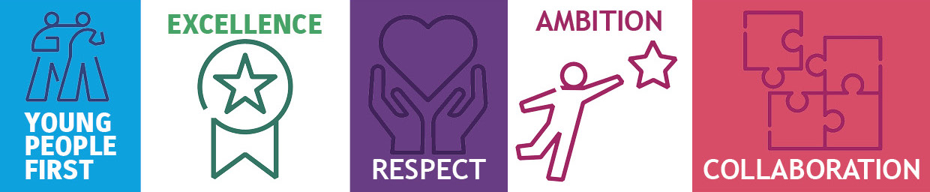
OUR VALUES AND STAFF BENEFITS:
